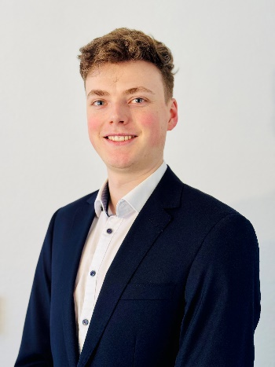
Sebastian Steinhäuser
Mechanical Engineer, B.Sc.

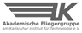
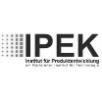




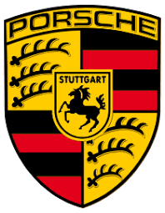
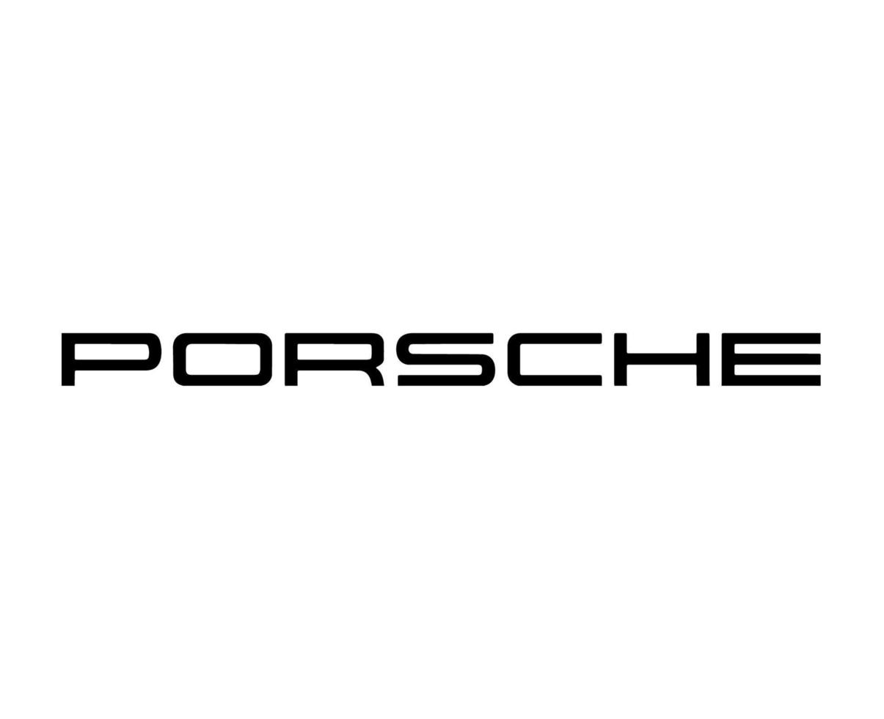


10/2023 - Present Research Assistant - Institute of Fluid Mechanics (ISTM) at KIT

11/2019 – 06/2024 Member in University Group - Academic Flying Group „Akaflieg Karlsruhe “

04/2022 – 08/2022 Internship - Dr. Ing. h.c. F. Porsche AG at Weissach,

05/2021 – 7/2021 University Tutor - Institute for Product Development (IPEK) at KIT

10/2016 Internship - Porsche Center Mannheim

Work Experience

Research topic Droplet Impact
- Set up and conduct experiments regarding Droplet Impact to generate a 3D droplet shape from a 2D image
- Developing a method for Distortion Correction using Raytracing in Blender
Researching, building and flying gliders
- Project management for the reconstruction of a glider
- Maintenance and repair of gliders
Department for Construction of Bodyshell (EKR3)
- Participation in test on the complete vehicle leak test bench
- Supporting the preparation of test vehicles and test setups for leak tests
- Contributing to the development and maintenance of a complete overview of all relevant test specifications for the department
Tutor of mechanical engineering IV
- Support and advice for student working groups
- Conducting colloquia
Mechatronics department
- Maintenance, repair, diagnosis and repair work on Porsche cars
- Removal/dismantling, disassembly and damage assessment of engines and units
Personal Competence
- Strengths in presentations
- Social competence
- Interested in new technologies
- Enthusiastic
- Self-motivated
- Willingness to travel
- Strong communication skills
- Quick comprehension of complex issues
- Analytical-conceptual and goal-oriented thinking
- Openness and sociability
Personal Information

Viktoriastraße 12,
76133 Karlsruhe, Germany

sebastian@die-steinhaeuser.de

+49 151 56064987

11.03.2000







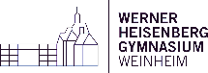

Language Skills

German (native)
English (fluent, C1/C2)

Computer Skills

Microsoft-Office (proficient)

Programming Languages:
Matlab (intermediate)

Computer Aided Design:
Catia, Creo

Blender (intermediate)

Driving license
class B
04/2023 – 09/2026 M.Sc. Mechanical Engineering Candidate - Karlsruhe Institute of Technology (KIT)

10/2018 – 03/2023 B.Sc. Mechanical Engineering - Karlsruhe Institute of Technology (KIT)

09/2010 – 05/2018 High School – Werner Heisenberg Gymnasium in Weinheim
- Specializations: Fluid Mechanics, Vehicle Dynamics, Vehicle Comfort and Acoustics (NVH)
- Current Grade Point Average: 2.0
- Specialization: Automotive Engineering
- Thesis: Adaption of a High-speed Background Oriented Schlieren Method using Far-field Microscopy Using Ignition Sparks as an Example, Grade: 1.7
- Grade Point Average: 2.5
- Grade Point Average: 1.3
Education
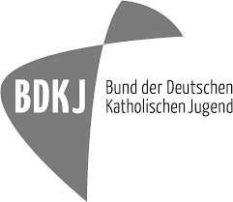

04/2021 – 09/2021 ‘Start in Teaching’ - Tutor Program – PEBA at Karlsruhe Institute of Technology (KIT)

01/2021 Remote pilot license A1/A3 – EASA/LBA

11/2015 and 03/2016 Youth Group Leader Basic Course - BDKJ - Federation of German Catholic Youth

08/2016 Language Trip -Weymouth, England

08/2015 Language Trip – Christchurch, England
Deanery Heidelberg-Weinheim
- Qualification focus: Group pedagogy, Methodology and didactics, Culture of respect
- Following: KjG Group leader at 3 camps with around 100 children in the Years until 2018
- Participation in a 2-week language school for english
- Participation in a 2-week language school for english
- Planning and structuring tutorials for specific target groups
- Preparing complex subject content for learning
- Stimulate and support active and independent learning
- Completion of remote pilot license A1/A3 (for drones, UAS)
Additional training courses

